2/10/2019

Group 3

Hospital Management System

Technical Documentation

1. INTRODUCTION

SYSTEM REQUIREMENTS……………………………………………………2

CONNECTION ESTABLISHMENTS…………………………………………3

Database……………………………………………………………………3

1. LOG IN SYSTEM

GENERATING THE HASH VALUE…………….………………………………4

CHECKING THE HASH VALUE AND OTHER CODE………………...........5

1. INSERTION INTO DATABSE

STAFF INSERTION………………………………………………………………7

MEDICINES INSERTION…………………………………………………….….8

UPDATING DATA………………………………………………………………9

1. FLOW CHARTS AND OTHERS

MAIN PAGE………………………………………………………………………10

ADMIN PAGE…………………………………………………………………….11

PHARMACY PAGE………………………………………………………………11

Improvements…………………………………………………………………...12

1. INTRODUCTION

This Software is made with the use of Microsoft visual Basic and MS Access database.

SYSTEM REQUIREMENTS

* It occupies 10-12 MB of RAM.
* The System Support MS ACCESS Database.

CONNECTION ESTABLISHMENTS

* Access database is used as database in the software.
* And that Database is added in the software.
* After the Adding Connection software establish connection as con, just after form loads . The code used for establishment is as :

Dim path As String = Directory.GetCurrentDire

ctory

path = Directory.GetParent(path).ToString

path = Directory.GetParent(patyh).ToString

Dim connectionstring As String = “provider=Microsoft.ACE.OLEDB.12.0 ; data source = “ & path & “\hms_Database.accdb”

Database

Access database is used for Database management.

The tables and fields are:

1. Appointment_DataBase: For Appointments storing.
2. Billing_Database: For Billing, Storing Costumers details and data.
3. Doctot_DataBase: For Storing Doctor database.
4. Emergency_DataBase: Emergency Database
5. Laboratorist_DataBase: Laboratorists DataBase.
6. Nurse_DataBase: Nurse DataBase.
7. OPD_DataBase: OPD Database.
8. Patient_DataBAse: For Storing Patient DataBase
9. Pharmacist_DataBase: For Storing pharmacist database.
10. Pharmacy_DataBase: For Storing Medicines data
11. Room_DataBase: For Storing Room Allotment Database
12. RoomAllocation_DataBase: For room Details
13. Password_Database: For Passwords of Admin,Pharmacist,staff
14. LOG IN SYSTEM

* The Initial Log In Details for

1.Admin: [Username:admin],[Password:admin]

2.Pharmacist: [Username:pharmacist],[Password:pharmacist]

3.Staff: [Username:staff],[Password:staff]

***These can only be changed by the admin

* For taking Inputs Textboxes are used.
* Sign up needed for patient only.
* On clicking Log in the software generates the hash value for inputs and then checks with that of stored in database. A Function has been made to generate hash values for username and password.
* If the Hash value matches with that in the system for those password and user name then it will show another form for patient with message “Login Successful”. otherwise in case of mismatching shows a message box saying “ Username or password is correct”.

GENERATING THE HASH VALUE

The Hash Function Generator code is as follows:

#Region “Functions”

Private Function StringtoMd5(ByRef Content As String) As String

Dim M5 As New System.Sequrity.Cryptography.MD5CryptoServiceProvider

Dim ByteString() As Byte =System.Text.Encoding.ASCII.GetBytes(Content)

ByteString = M5.ComputeHash(ByteString)

Dim FinalString As String = Nothing

For Each bt As Byte In ByteString

FinalString &= bt.ToString(“x2”)

Next

Return FinalString.ToUpper()

End Function

#End Region

CHECKING THE HASH VALUE AND OTHER CODE

After Successfully generating the hash Value Software compares the two hash values. And Provide the appropriate Message.

Connection is Established as con.

Try

con.ConnectionString = connectionstring

Dim dt As New DataTable

Dim da As New OleDbDataAdapter

Dim username As String = “Username input”

Dim password As String = CType(StringtoMd5(“Password input”),String)

Dim query As String = “”

Dim id_display As Int16

query = “Select * From Database where Username_field_name = ‘” & username & “’ And

Password_field = ‘”& password & “’”

con.Open()

Dim cmd As New OleDbCommand(query, con)

Da.Filll(dt)

For Each row As DataRow In dt.Rows

For Each column AS DataColumn In dt.Columns

If column.ColumnName = “ID” Then

Id_display = row(column)

End If

Next

Next

Dim reader As OleDbDataReader

Reader = cmd.ExecuteReader()

Dim count As Integer =0

While (reader.Read)

Count+=1

End While

con.Close()

If (count <> 1) Then

MessageBox.show(“UserNAme or Password is incorrect!”)

Else

New_Form_to_show.user.text = id_display

New_Form_to_show.show()

Me.Close()

End If

Catch ex As Exception

MessageBox.Show(ex.Message)

End Try

3.INSERTION INTO DATABSE

* Inserting data for staff can only be done by Admin.
* Pharmacy data can be inserted by admin as well as pharmacist person.

Staff insertion

Admin add the details of the person and generate username and password for them.

On giving all the inputs and pressing the button add software adds the details in database.

Demonstration of the code is as follows:

# Establish Connection

# check for all the inputs are they all valid and present

# Generate query string

con.Open()

Dim insertString As String =” Insert into Databse ( [ field1_name ] ,

[fiels2_name ],…..,[fieldi_name] ) Values(?,?,?,…….,?)”

Dim cmd As OleDbCommand =New OleDbCommand (insertString, con)

Cmd.Parameter.Add(New OleDbParameter(“field1”,CType(input1.Text , String)))

# for other fields also same

.

.

.

.

Cmd.Parameter.Add(New OleDbParameter (“UserName”, CType (user_name_input.Text , String)))

Cmd.Parameter.Add(New OleDbParameter(“Password”,CType( StringtoMd5 ( password_input.Text ) , String )))

Try

Cmd.ExecuteNonQuery()

Cmd.CommandText = “SELECT @@IDENTITY”

MessageBox.Show(“ID” & cmd.ExecuteScalar.ToString, “Successful

Added “)

# Clear all input textboxes

Catch ex As Exception

# Show Error Message

End Try

Con.Close()

This will generate an ID number for the Employee Automatically.

Medicine Insertion

Medicine Insertion takes place only when Eid is Correct. Eid is like a number with first 3 characters and 4 letters after that.

The simple format will take place it will take all the details of medicine like Eid, Name, Rate, Expiry Date, quantity).

Gives error when something went wrong like Eid exists in data or Eid is wrong.

Clear Button Just Clears all the data in input boxes like it

TextBox1.Clear()

Close Button Just Exit the button.

Add Button: checks if primary key is present or not if present then give error.

The code is just Same as for staff insertion.

Searching

Searching is just done in FlowLayout Panel format.

In which a Combobox is used to sort the search data. Text Box is Inserted For Typing for the value of the attribute selected in combobox.

Searching in database takes place when the flowlayou

1. Flow Charts and others

Main Page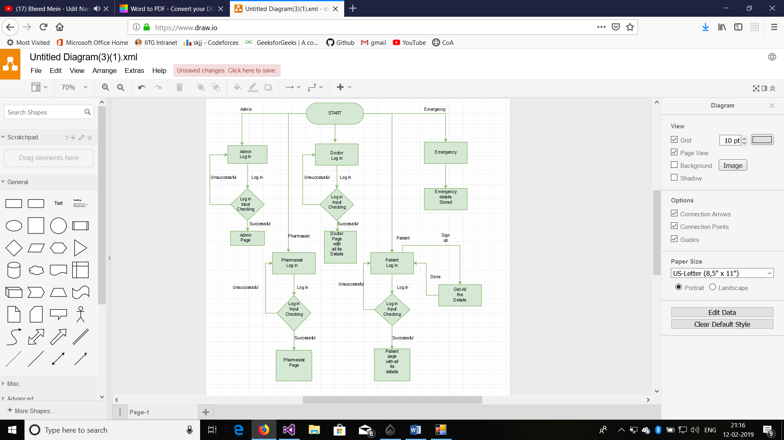Figure / Flow Chart For Main Page

Admin Page

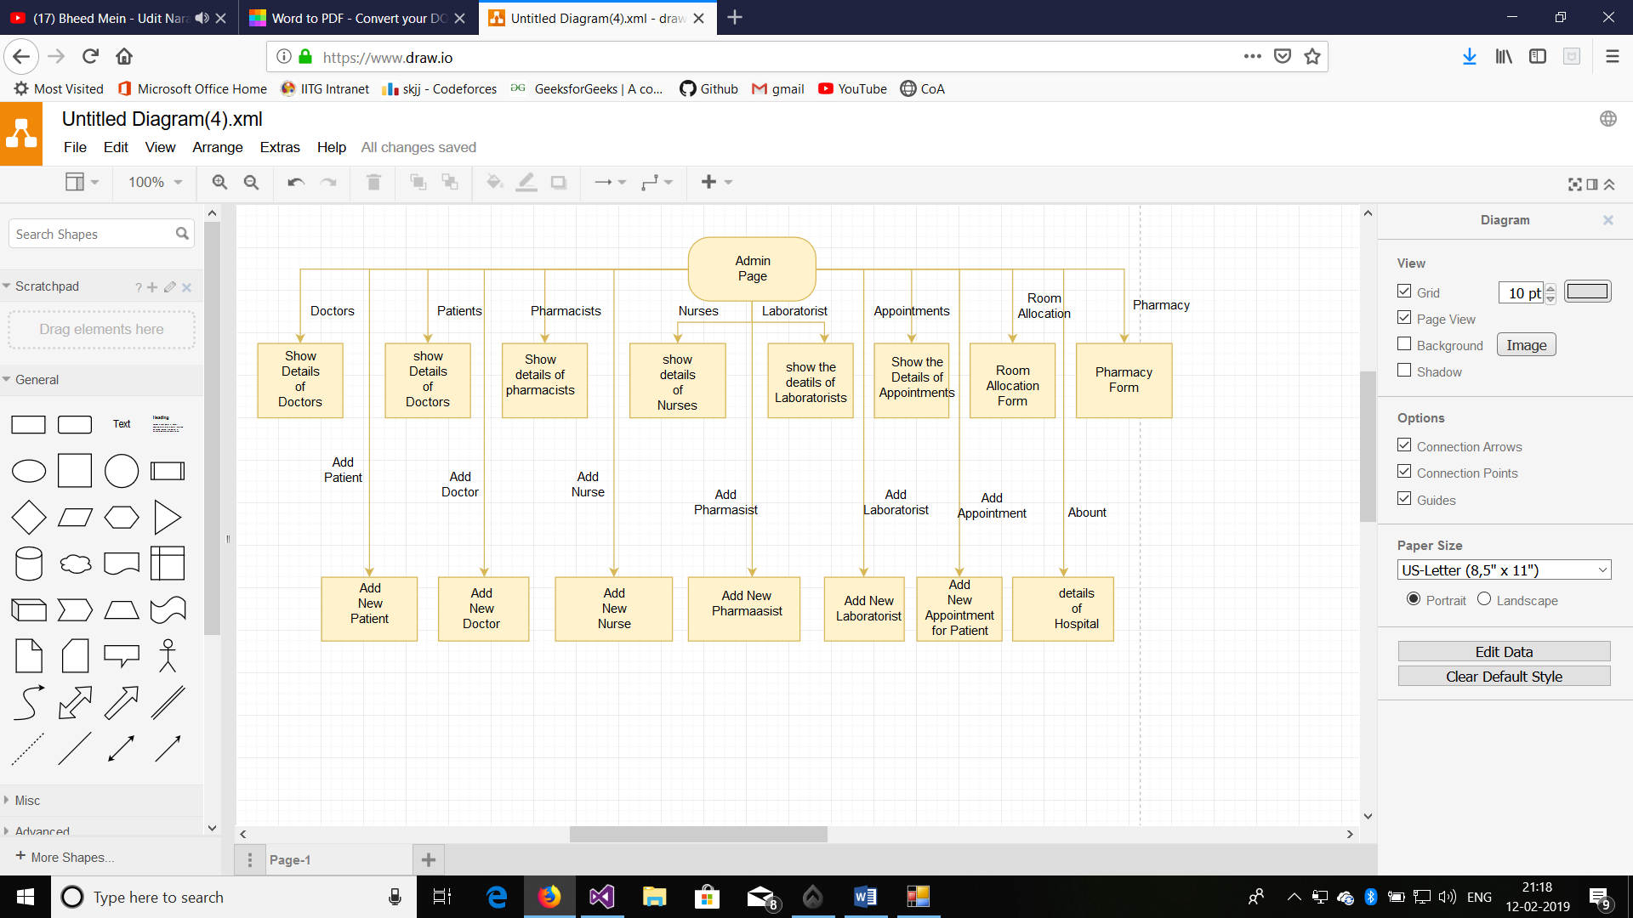

Figure Flow Chart For Admin

Pharmacy Page

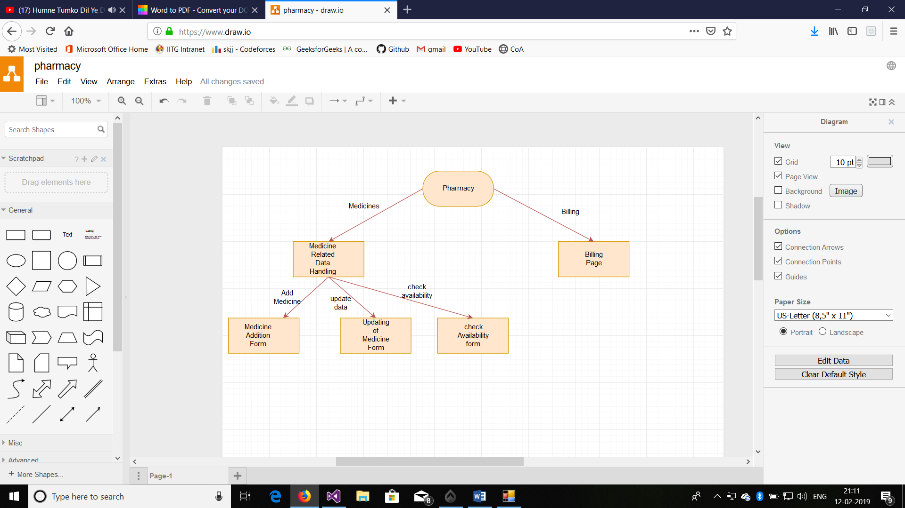

Figure / Flow Chart For Pharmacy

Improvements

* News and feedback forms can be implemented.
* In Billing more data should be stored like list of prescriptions.
* Data deletion option will be more helpful.

**COPYRIGHT INFORMATION**

**SHUBHAM KUMAR 170101064**

**KEERTI HARPAVAT 170101031**

**P.R.S RAKESH GUPTA 170101050**

**K. NAVEEN 170101032**

**PRABHAT KUMAR 170101046**